Double Bar Graph
Double Bar Graph
A simple bar graph represents one set of data. For e.g score of students in a Maths.
A bar graph is drawn in a similar way to simple bar graph.
A double graph represents two sets of data in one graph. For eg score of students in Maths and Hindi.

Example : Let there be 4 students A,B,C and D. The total marks for both hindi and Maths test is 40.Simple and double bar graphs can be obtained as:
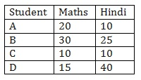
First of all draw a horizontal line and a vertical line.
On the horizontal line we will write the names of students and on vertical line we will write scores of maths and hindi.
The scale taken is 1 unit = 5 marks.
In a double bar graph both scores of both hindi and maths is marked. For e.g where Student is marked on Horizontal axis, two bars are drawn representing the bars of hindi and maths respectively. This is done for all the students.
Same data can also be represented by interchanging the items on horizontal and vertical axis.
The height of the bar represents the score of a student.
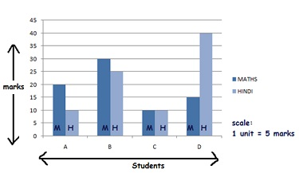
Double Bar Graph( Both hindi and maths score)

Problem: The performance of students in 1st Term and 2nd Term is given. Draw a double bar graph choosing appropriate scale and answer the following:
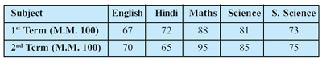
Firstly, we take the subjects on horizontal axis and marks on the y axis.
The scale taken is 1unit = 10 marks.
The height of the bar represents the marks in a given test.
We get a double bar graph in which dark color represents term 1 and light color represents term 2.
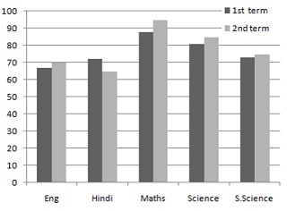
In which subject, has the child improved his performance the most?
The subject in which child has improved will have a taller term 2 bar than term1.The bar for the subject maths has the maximum difference between the height of the bars representing term 1 and term 2. Hence, the child has improved his performance in maths the most.
In which subject is the improvement the least?
The subject in which child has improved will have a term 2 bar that is marginally greater or equivalent to term1 bar. So, in social science the improvement is least.
Has the performance gone down in any subject?
The subject with a term 2 bar shorter than the term 1 bar is subject in which the student has gone down. Hence, the performance has gone down in Hindi.

